WEEK 2 ASSESSMENT REPORT
Data Visualization and Insight Communication Using R
India Air Quality Analysis (2020–2025)
Submitted by | Nandhana S
Programme | M.Sc. Data Science
Tool Used | R / RStudio
Visualization Library | ggplot2
Dataset | India Air Quality Dataset
Dataset Period | 1 January 2020 – 31 October 2025

1. Introduction
This Week 2 assessment focuses on data visualization and insight communication using R. The India Air Quality dataset used in Week 1 was continued for this analysis. The objective was to create clear visualizations that communicate distributions, category differences, temporal trends, monthly variation, and city-level differences to a non-technical audience.
The analysis was performed using RStudio and ggplot2. Five visualizations were developed: an AQI histogram, an air-quality category bar chart, a yearly average AQI line chart, a monthly AQI boxplot, and a top-10 cities bar chart. Each visualization was selected for a specific analytical purpose.

2. Dataset Overview
The dataset contains 378,328 observations covering 1 January 2020 to 31 October 2025. The main variables used for visualization were Date, City, Air.Quality, and AQI.Value.
Variable | Description | Visualization Role
Date | Date of observation | Year and Month
City | City associated with the observation | City comparison
Air.Quality | Air-quality category | Category distribution
AQI.Value | Numerical AQI value | Distribution, trend and variation

library(ggplot2)
file_path <- "C:/Users/nandh/OneDrive/Desktop/YuvaIntern_AQI_Analysis/AQI_2020_to_2025_October.csv"
aqi <- read.csv(file_path, stringsAsFactors = FALSE)
aqi$Date <- as.Date(aqi$Date, format = "%d-%m-%Y")
aqi$Month <- format(aqi$Date, "%B")
aqi$Year <- format(aqi$Date, "%Y")

3. Visualization Design
Visualization choices were based on the type of variable and the question being answered. A histogram was used for the numerical AQI distribution, a bar chart for categorical frequencies, a line chart for yearly trends, a boxplot for monthly variation and potential anomalies, and a horizontal bar chart for city comparison.

4. Visualization 1 – Distribution of AQI Values
p1 <- ggplot(aqi, aes(x = AQI.Value)) +
geom_histogram(bins = 50) +
labs(title = "Distribution of AQI Values",
subtitle = "India Air Quality Dataset, 2020–2025",
x = "AQI Value", y = "Number of Observations") +
theme_minimal()
print(p1)
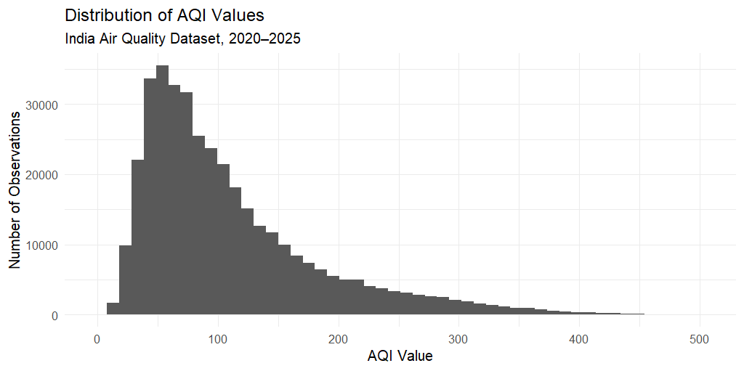
Figure 1: Distribution of AQI Values
Interpretation: The histogram shows that many observations are concentrated at lower and middle AQI values. The distribution has a long right tail toward high AQI values, showing that very high observations occur less frequently but extend to substantially higher levels.

5. Visualization 2 – Distribution of Air Quality Categories
p2 <- ggplot(aqi, aes(x = Air.Quality)) +
geom_bar() +
labs(title = "Distribution of Air Quality Categories",
x = "Air Quality Category", y = "Number of Observations") +
theme_minimal()
print(p2)
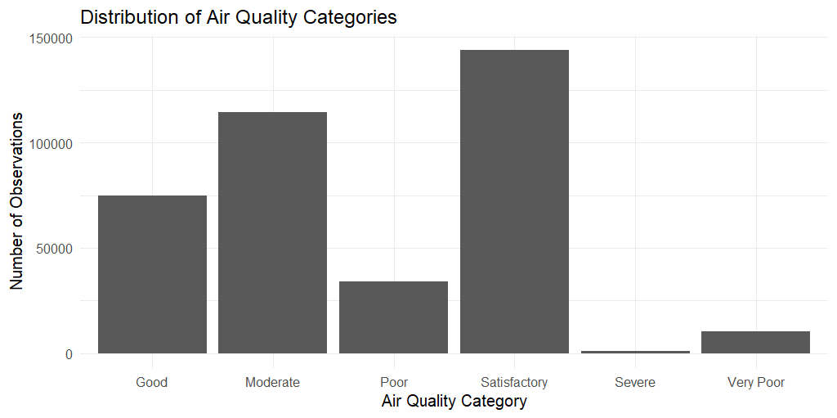
Figure 2: Distribution of Air Quality Categories
Interpretation: The Satisfactory category is the most frequent, followed by Moderate and Good. Poor and Very Poor have fewer observations, while Severe is the least frequent category.

6. Visualization 3 – Average AQI by Year
yearly_aqi <- aggregate(AQI.Value ~ Year, data = aqi, FUN = mean)
p3 <- ggplot(yearly_aqi, aes(x = Year, y = AQI.Value, group = 1)) +
geom_line() + geom_point() +
labs(title = "Average AQI by Year",
x = "Year", y = "Average AQI") +
theme_minimal()
print(p3)
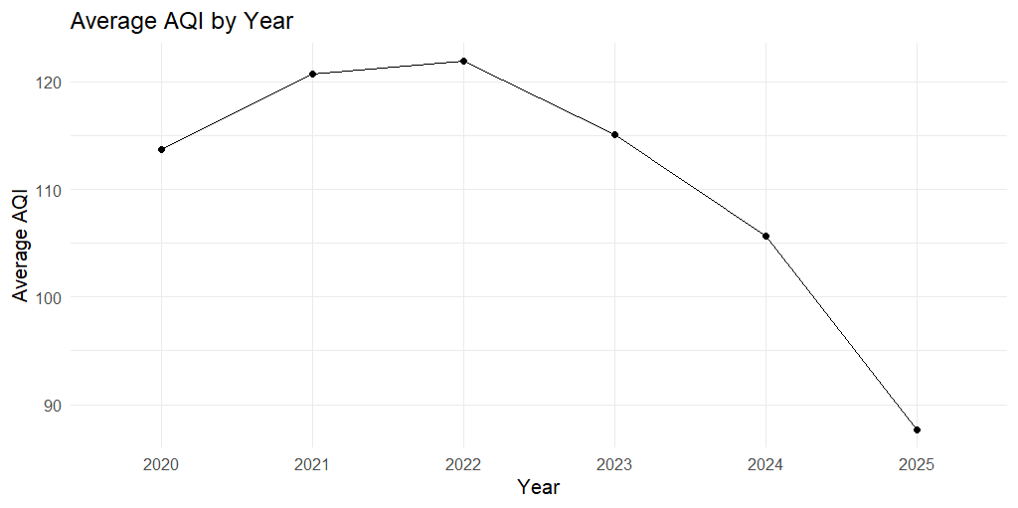
Figure 3: Average AQI by Year
Interpretation: Average AQI increased from 113.75 in 2020 to 120.77 in 2021 and peaked at 121.92 in 2022. It then declined to 115.09 in 2023 and 105.69 in 2024. The 2025 average is 87.66, but 2025 is incomplete because the dataset ends on 31 October 2025.

7. Visualization 4 – Monthly Variation in AQI
p4 <- ggplot(aqi, aes(x = Month, y = AQI.Value)) +
geom_boxplot() +
labs(title = "Monthly Variation in AQI",
x = "Month", y = "AQI Value") +
theme_minimal() +
theme(axis.text.x = element_text(angle = 45, hjust = 1))
print(p4)
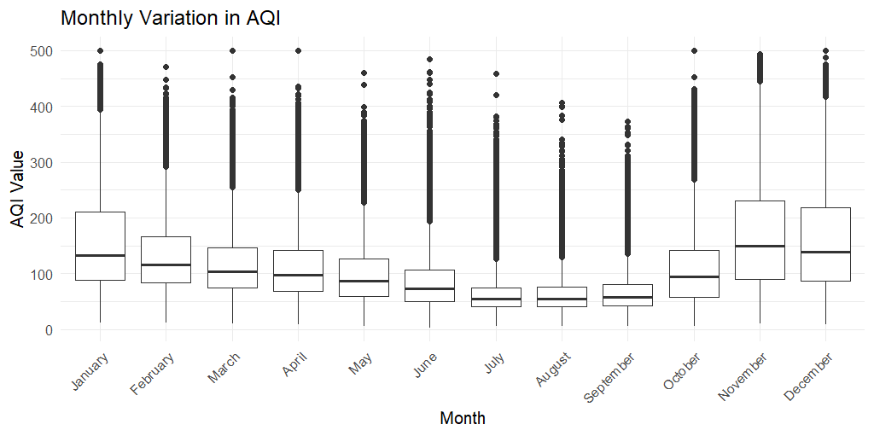
Figure 4: Monthly Variation in AQI
Interpretation: The monthly boxplot shows differences in central AQI values and spread across the year. Several winter months show relatively higher central AQI levels, while many high-value observations extend toward the upper AQI range across multiple months.

8. Visualization 5 – Top 10 Cities by Average AQI
city_aqi <- aggregate(AQI.Value ~ City, data = aqi, FUN = mean)
city_aqi <- city_aqi[order(-city_aqi$AQI.Value),]
top10_cities <- head(city_aqi, 10)
p5 <- ggplot(top10_cities,
aes(x = reorder(City, AQI.Value), y = AQI.Value)) +
geom_col() + coord_flip() +
labs(title = "Top 10 Cities by Average AQI",
x = "City", y = "Average AQI") +
theme_minimal()
print(p5)
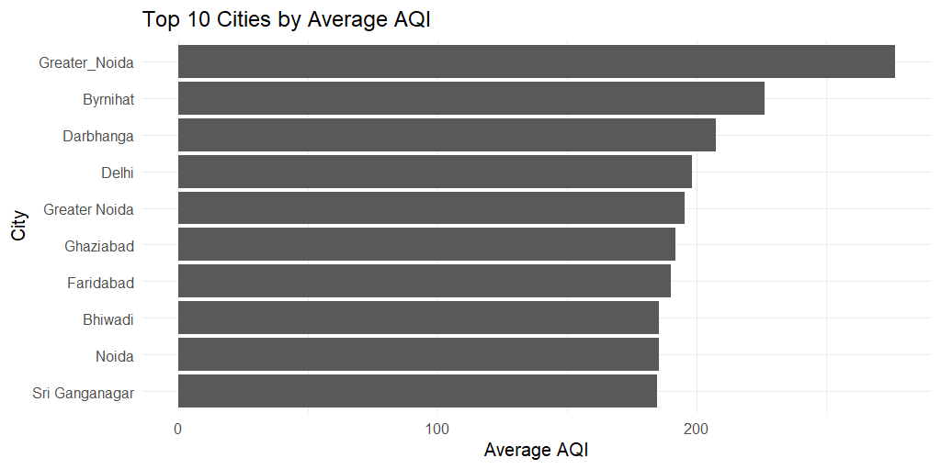
Figure 5: Top 10 Cities by Average AQI
Interpretation: The city-level chart shows substantial differences in average AQI. Greater_Noida has the highest average among the labels shown, followed by Byrnihat and Darbhanga. The chart reflects the city labels as represented in the dataset.

9. Key Insights
- The AQI distribution is concentrated toward lower and middle AQI values with a long right tail.
- Satisfactory is the most frequent air-quality category, followed by Moderate and Good.
- Average AQI increased from 2020 to 2022 and reached its highest annual value of 121.92 in 2022.
- Average AQI declined in 2023 and 2024 after the 2022 peak.
- The 2025 average is lower, but 2025 is incomplete because observations end on 31 October.
- Monthly boxplots show differences in AQI distributions and reveal numerous high-value observations.
- The city comparison shows substantial differences in average AQI among the highest-average city labels.

10. Insight Communication
The visualizations convert a large table of 378,328 observations into a small set of understandable messages. The histogram communicates the overall shape of AQI values, the category chart shows which air-quality classifications are most common, the line chart communicates the yearly direction, the boxplot shows monthly variation, and the city chart highlights locations with higher average AQI. Together, these charts make the main patterns easier to understand without examining the raw dataset.

11. Limitations
- 2025 is not a complete calendar year because the dataset ends on 31 October 2025.
- The city visualization reflects city labels exactly as represented in the source dataset.
- These visualizations describe patterns and do not establish causal relationships.
- The analysis focuses on the variables available in the selected dataset.

12. Conclusion
This Week 2 assessment demonstrated the use of R and ggplot2 to communicate insights from an India Air Quality dataset covering 2020 to October 2025. Five complementary visualizations were developed to examine AQI distribution, air-quality categories, yearly trends, monthly variation, and city-level differences. The analysis shows that AQI values are concentrated toward lower and middle ranges but include a long tail of high values; Satisfactory is the most common category; average AQI peaked in 2022 among the years shown; and AQI distributions vary across months and cities. The work demonstrates how appropriate chart selection and clear interpretation can transform a large dataset into understandable insights.

13. R Code Appendix
# Load package
if (!requireNamespace("ggplot2", quietly = TRUE)) install.packages("ggplot2")
library(ggplot2)
# Load data
file_path <- "C:/Users/nandh/OneDrive/Desktop/YuvaIntern_AQI_Analysis/AQI_2020_to_2025_October.csv"
aqi <- read.csv(file_path, stringsAsFactors = FALSE)
# Prepare variables
aqi$Date <- as.Date(aqi$Date, format = "%d-%m-%Y")
aqi$Month <- factor(format(aqi$Date, "%B"), levels = month.name)
aqi$Year <- format(aqi$Date, "%Y")
# 1. Histogram
ggplot(aqi, aes(x = AQI.Value)) +
geom_histogram(bins = 50) +
labs(title = "Distribution of AQI Values",
x = "AQI Value", y = "Number of Observations") +
theme_minimal()
# 2. Category bar chart
ggplot(aqi, aes(x = Air.Quality)) +
geom_bar() +
labs(title = "Distribution of Air Quality Categories",
x = "Air Quality Category", y = "Number of Observations") +
theme_minimal()
# 3. Yearly line chart
yearly_aqi <- aggregate(AQI.Value ~ Year, data = aqi, FUN = mean)
ggplot(yearly_aqi, aes(x = Year, y = AQI.Value, group = 1)) +
geom_line() + geom_point() +
labs(title = "Average AQI by Year",
x = "Year", y = "Average AQI") +
theme_minimal()
# 4. Monthly boxplot
ggplot(aqi, aes(x = Month, y = AQI.Value)) +
geom_boxplot() +
labs(title = "Monthly Variation in AQI",
x = "Month", y = "AQI Value") +
theme_minimal()
# 5. Top 10 cities
city_aqi <- aggregate(AQI.Value ~ City, data = aqi, FUN = mean)
city_aqi <- city_aqi[order(-city_aqi$AQI.Value),]
top10_cities <- head(city_aqi, 10)
ggplot(top10_cities,
aes(x = reorder(City, AQI.Value), y = AQI.Value)) +
geom_col() + coord_flip() +
labs(title = "Top 10 Cities by Average AQI",
x = "City", y = "Average AQI") +
theme_minimal()
# Summary outputs
print(yearly_aqi)
print(top10_cities)
print(table(aqi$Air.Quality))
print(range(aqi$Date))

